 CHEMICAL ENGINEERING TRANSACTIONS  VOL. 86, 2021 | A publication of  
The Italian Association
of Chemical Engineering
Online at www.cetjournal.it
Guest Editors: Sauro Pierucci, Jiří Jaromír Klemeš
Copyright © 2021, AIDIC Servizi S.r.l.
ISBN 978-88-95608-84-6; ISSN 2283-9216

Microbial Pb(II) precipitation: the role of biosorption as a Pb(II) removal mechanism
Brandon van Veenhuyzenª, Evans M.N. Chirwaª, Hendrik G. Brink^{a,}*
ªDepartment of Chemical Engineering, Faculty of Engineering, Built Environment and Information Technology, University of
Pretoria, Pretoria, South Africa
deon.brink@up.ac.za
This study investigated the role of biosorption in the precipitation of Pb(II) out of solution by an industrially obtained consortium. Previous investigations with this consortium have demonstrated Pb(II) removal from solution taking place in a two-phase (rapid and slow) system. This study focused on confirming whether the initial, rapid phase of removal is caused by the abiotic mechanism of biosorption before precipitation occurs.
Cultures were prepared under anaerobic conditions for 24 hours in batch reactors starting with 20 g L⁻¹ tryptone, 10 g L⁻¹ yeast extract, 1.0 g L⁻¹ NaCl and 0.43 g L⁻¹ NaNO₃. Bacteria purposed for studying abiotic Pb(II) removal through biosorption were suspended in 50 mM of sodium azide (NaN₃) solution for 3 hours to successfully inhibit the microbial respiratory chain, thereby preventing bacteria growth and activity. Fourier-transform infrared spectroscopy (FTIR) was used to inspect whether NaN₃ deformed the structure of bacteria cell walls and changed material characteristics.
Reactors containing 100 mL of 80 mg L⁻¹ Pb(II) and 1.0 g/L NaCl were spiked with 1 mL of NaN₃-sterilized bacteria culture and sampled over a 3 h period. Bulk Pb(II) concentration and metabolic activity were measured.
Results showed that NaN₃ is an effective means to cease metabolic activity of the consortium without altering the surface properties. Pb(II) is still removed from solution (61.7 %) by dead bacteria after NaN₃ sterilization, indicating that the initial rapid Pb(II) removal phase is an abiotic process. Functional groups associated with biosorption of heavy metals such as carboxyl, amine, and phosphate were identified as playing a role in Pb(II) removal with FTIR.
This consortium shows promise not only as a means for Pb(II) recovery in the form of precipitate but also as an attractive biosorption material to remove Pb(II) ions from wastewater.
  - Introduction
Modern industrial activities, such as mining and battery manufacturing, continue to introduce lead pollutants into the environment. This results in the rapid depletion of global reserves and the introduction of lead pollutants into the environment. Lead is highly toxic and has been found to accumulate through different trophic levels of ecosystems (Naik et al., 2013)⁠. It serves no biological purpose, but rather harms organisms directly by damaging cell structure or indirectly by impairing enzymes and substituting cationic nutrients. These two issues highlight the need for lead removal from wastewater and lead recovery for recycling back into the economy.
Most conventional approaches to addressing lead pollution involve immobilizing Pb(II) ions from waste water streams or converting it to a less harmful state, but require additional processing to confront the recovery of Pb(0). These include adsorption, membrane filtration, electrodialysis, ion exchange, chemical precipitation, and electrochemical treatment. Most of these techniques are favourable due to high selectivity, but are burdened with high operating energy requirements and prove uneconomical for treating waste water with low concentrations of Pb(II) (Fu and Wang, 2011). Bioremediation, on the other hand, is found to be an attractive alternative due to low operating cost and high remediation efficiency (Kang et al., 2015).
A microbial consortium sourced from lead contaminated soil at a battery recycling plant in South Africa has been shown to remove 90 % of Pb(II) from an 80 mg L⁻¹ solution over a period of 7 days and using Lysogeny broth as substrate (Brink et al., 2017). It has been shown that ionic lead in solution is converted to PbS or reduced to elemental Pb by the microbes (Brink, Hörstmann, and Feucht, 2019). Kinetic studies with this consortium have demonstrated two distinct phases of lead removal, a rapid phase followed by a slower phase (Hörstmann et al., 2020).
Various Pb-resistance strategies are present in micro-organisms, including intracellular bioaccumulation, extracellular sequestration, surface biosorption, bioprecipitation, cell morphology alteration and metal-ligand complex formation (Naik et al., 2013). SEM analyses on the battery recycling plant consortium indicated that surface Pb(II) bioprecipitation was the dominant lead removal mechanism (Hörstmann et al., 2020) in the slow phase.
This study serves to investigate whether biosorption is responsible for the initial, rapid phase of Pb(II) removal that acts as a vehicle for concentrating Pb(II) on the surface of the bacteria before bioprecipitation takes place.
The biosorption of heavy metals with bacteria has been widely studied. Several species of bacteria have demonstrated significant Pb(II) biosorption, including Bacillus firmus (Salehizadeh and Shojaosadati, 2003), Micrococcus luteus (Puyen et al., 2012), Pseudomonas putida (Uslu and Tanyol, 2006), Pseudomonas aeruginosa (Chang et al., 1997), and Streptomyces rimosus (Selatnia et al., 2004). The chemical composition of bacteria surfaces for both Gram-positive and Gram-negative bacteria are rich in negatively charged functional groups that result in an overall negative surface charge which facilitates the attraction of positively charged metal cations (Vijayaraghavan and Yun, 2008). These functional groups also allow for chemisorption to take place, where hydrogen ions are exchanged for Pb(II) ions (Lu et al., 2012). Chemisorption not only prevents lead from entering cells, but allows for the concentration of lead to be used as a terminal electron acceptor in bioprecipitation (Haas et al., 2001).
  - Materials and methods
    - Material preparation
Cultures were prepared in sterile batch reactors from 0.2 mL of battery recycling plant consortium frozen at -60 °C. The 100 mL growth suspension contained 20 g L⁻¹ tryptone, 10 g L⁻¹ yeast extract, and 1.0 g L⁻¹ NaCl (Hörstmann et al., 2020). Culture preparation was done in the absence of lead, but 0.43 g L⁻¹ NaNO₃ was added to ensure that bacteria were still provided with nitrates previously supplied from Pb(NO₃)₂ in experiments done by Hörstmann et al. (2020). Batch reactors were purged with nitrogen for 3 min to ensure anaerobic conditions (Peens et al., 2018) and left to grow in a shaker-incubator for 24 h, 35 °C and 120 rpm. To successfully inhibit the microbial respiratory chain and ensure Pb(II) removal through biosorption alone, the culture was exposed to 50 mM of NaN₃ (Cabrol et al., 2017) for 3 h after the 24 h growth period.
    - Metabolic activity measurement
Metabolic activity was measured with 3-(4,5-dimethylthiazol-2-yl)-2,5-diphenyl tetrazolium bromide (MTT). MTT is a yellow dye which is reduced to formazan crystals by the dehydrogenase system of viable gram-negative bacterial cells. MTT solution was prepared using 5 g L⁻¹ MTT in ultrapure water. For metabolic activity readings, filtered (0.45 µm) and unfiltered samples were diluted 4 times and mixed with MTT to form a 10% MTT solution. The solution was incubated for an hour, after which formazan crystals were dissolved by dimethyl sulfoxide. A spectrophotometer with light at 550 nm was used to measure light absorbed by solution and infer metabolic activity from the difference between filtered and unfiltered samples (Peens, 2018).
    - FTIR analysis
Fourier transform infrared (FTIR) spectra of the consortium were measured after the 24 h growth period, after 3 h exposure to 50 m NaN₃, and after exposure to 50 mM NaN₃ and 200 mg L⁻¹ Pb(NO₃)_{2.} Spectra were recorded on a Perkin Elmer Spectrum 2000GX FTIR spectrometer using an attenuated total reflection (ATR) attachment. All FTIR spectra were recorded at a resolution of 2 cm⁻¹ for 30 scans from 4000 to 550 cm⁻¹ and represent the average of 30 scans.
    - Lead removal experiments
Sterilized reactors containing 100 mL of ultrapure water with various concentrations of Pb(II) were spiked with NaN₃-sterilized bacteria. To maintain the same ionic strength as experiments done by Hörstmann et al. (2020), 1.0 g L⁻¹ NaCl was added. The removal of Pb(II) over a 3 h period was investigated by spiking triplicate reactors containing 80 mg L⁻¹ Pb(II) with 1.0 mL of bacteria. Reactors were sampled at various time intervals and filtered (0.45 µm).
The effect of initial Pb(II) concentration and bacteria concentration on Pb(II) removal was determined by setting up reactors with 1.0 g L⁻¹ NaCl, 50 – 400 mg L⁻¹ Pb(II), and 1.2 – 3.4 mL of bacteria culture. The dry mass of bacteria per mL of culture was determined by centrifuging the culture at 9000 rpm for 10 minutes at 4 °C, rinsing with distilled water, and centrifuging again before being oven dried at 50 °C for 24 h.
The Pb(II) concentration in samples was determined by atomic absorption spectroscopy (Perkin Elmer AAnalyst 400, Waltham, Massachusetts).
  - Results
    - FTIR analysis
The presence of functional groups was confirmed by FTIR analysis. In Figure 1, the broad peak found between was attributed to O-H stretching (Francioso et al., 2010), whereas the band at 1640 cm⁻¹ was assigned to the presence of -C=O in amide I (Y. Liu et al., 2016). The addition of NaN₃ appears to do little to affect the surface properties of the consortium. This is seen in Figure 1a) and Figure 1b). A difference between the two spectra is observed at 2040 cm⁻¹ in Figure 1b), with this band signaling the presence of N≡N from NaN₃ (Tao et al., 2011). The addition of Pb(II) results in a significant disruption in transmittance between 1550 and 900 cm⁻¹, as observed in Figure 1c). The appearance of new peaks could be indicative of the cell wall rupturing, resulting in the exposure of various functional groups from the interior off the cell. This consortium has been recorded growing in Pb(II) concentrations around 1000 mg L⁻¹ (Peens et al., 2018), making such destructive effects of 200 mg L⁻¹ Pb(II) on cell walls unlikely.
Alternatively, the appearance and strengthening of weak bands could show chemisorption of Pb(II) to particular surface functional groups. Bands are described as appearing if they were not discernable in the spectra of NaN₃-sterilized cultures but did became apparent in Figure 1c)Figure 3.
The appearance of a band at 1537 cm⁻¹ may be indicative of interference or deformation of N-H bending in amide II, and is suggestive of Pb(II) binding (Masoumi et al., 2016). The strengthening of the band at 1451 cm⁻¹ and subsequent shift to 1454 cm⁻¹ could signal Pb(II) interactions with CH₃ and CH₂ groups of lipids and proteins (Z. Liu et al., 2016). The strengthening and shift of the band at 1406 cm⁻¹ to 1393 cm⁻¹ is likely a result of COO⁻ groups (Dittrich and Sibler, 2005) binding with Pb(II). Additionally, the strengthening and shift of the 1240 cm⁻¹ band to 1235 cm⁻¹ could arise from lead binding with P=O functional groups of phosphorylated proteins or polyphosphate storage products (Dittrich and Sibler, 2005). The appearance of a band at 1030 cm⁻¹ may be attributed to a variety of mixed modes of carbohydrates (Z. Liu et al., 2016) or carboxyl groups (Lu et al., 2012). Finally, the appearance of a band at 956 cm⁻¹ is likely due to Pb(II) interfering with C=C bending in alkenes.
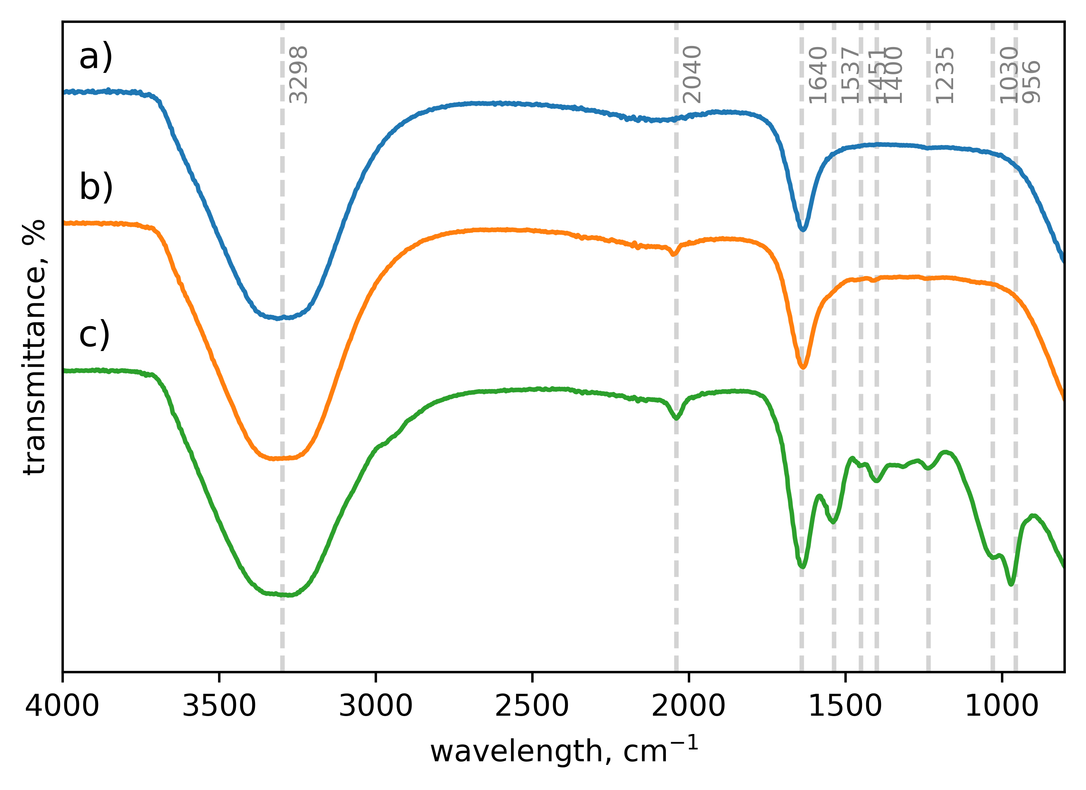
Figure 1: FTIR spectra of bacteria consortium a) after 24 h growth period, b) after 3 h exposure to NaN₃, and c) after exposure to NaN₃ and Pb(NO₃)₂.
These findings are consistent with literature reports of functional groups involved in the chemisorption of heavy metals to biomass, including carboxyl groups (Fomina and Gadd, 2014), amine (Fein et al., 1997), phosphate (Ngwenya et al., 2003), and carbonyl (Mathew and Krishnamurthy, 2018).
    - Lead removal experiments
Following 3 h, 61.7 ± 4.86 % of Pb(II) was removed from solution by NaN₃-sterilized bacteria (Figure 2). This compares with the 50 % removal by the battery recycling plant consortium observed in the rapid lead removal phase of previous studies with the living consortium (Hörstmann et al., 2020). The difference observed is likely due to more bacteria being dosed in the current study.
The rapid kinetics observed is typical of biosorption materials, comparable with Pb(II) removal by yeast reaching equilibrium after 6 min (Duncan et al., 2003), 95 % Pb(II) removal after 60 s by algae Spirulina sp. (Van Hille et al., 2003), and Pb(II) removal equilibrium being reached after 40 min by Curtobacterium sp. FM01 (Masoumi et al., 2016).
In addition, no metabolic activity was detected in any of the reactors using MTT. This indicates that a passive mechanism was involved in lead removal. The concentrations used were also found to be within the solubility range of Pb(N₃)₂ (Lieber et al., 1966), confirming that lead removal was caused by presence of the battery recycling plant consortium alone. No black/grey precipitate was discernable following a 24 h period, signaling a lack of PbS or Pb(0) formation.
As shown in Figure 2: Percent lead remaining in solution as a function of time after the addition of the NaN3-sterilized consortium. The red data point represents the percentage lead in solution for the living consortium after 3 h as measured by Hörstmann et al. (2020)., an increase in bacteria mass dosing was found to produce a clear increase in Pb(II) removal. This is presumably due to an increase in available sorption sites. An increase in initial Pb(II) concentration from 0 mg L⁻¹ to 100 mg L⁻¹ shows greater Pb(II) removal, presumably due to a stronger concentration gradient. A similar effect is seen with Pb(II) adsorption onto carbon nanofibers (Ahmed et al., 2010). Above 150 mg L⁻¹ a decrease in adsorption is observed with increases in initial Pb(II) concentration, indicating the limitation of adsorption sites being reached at these concentrations.
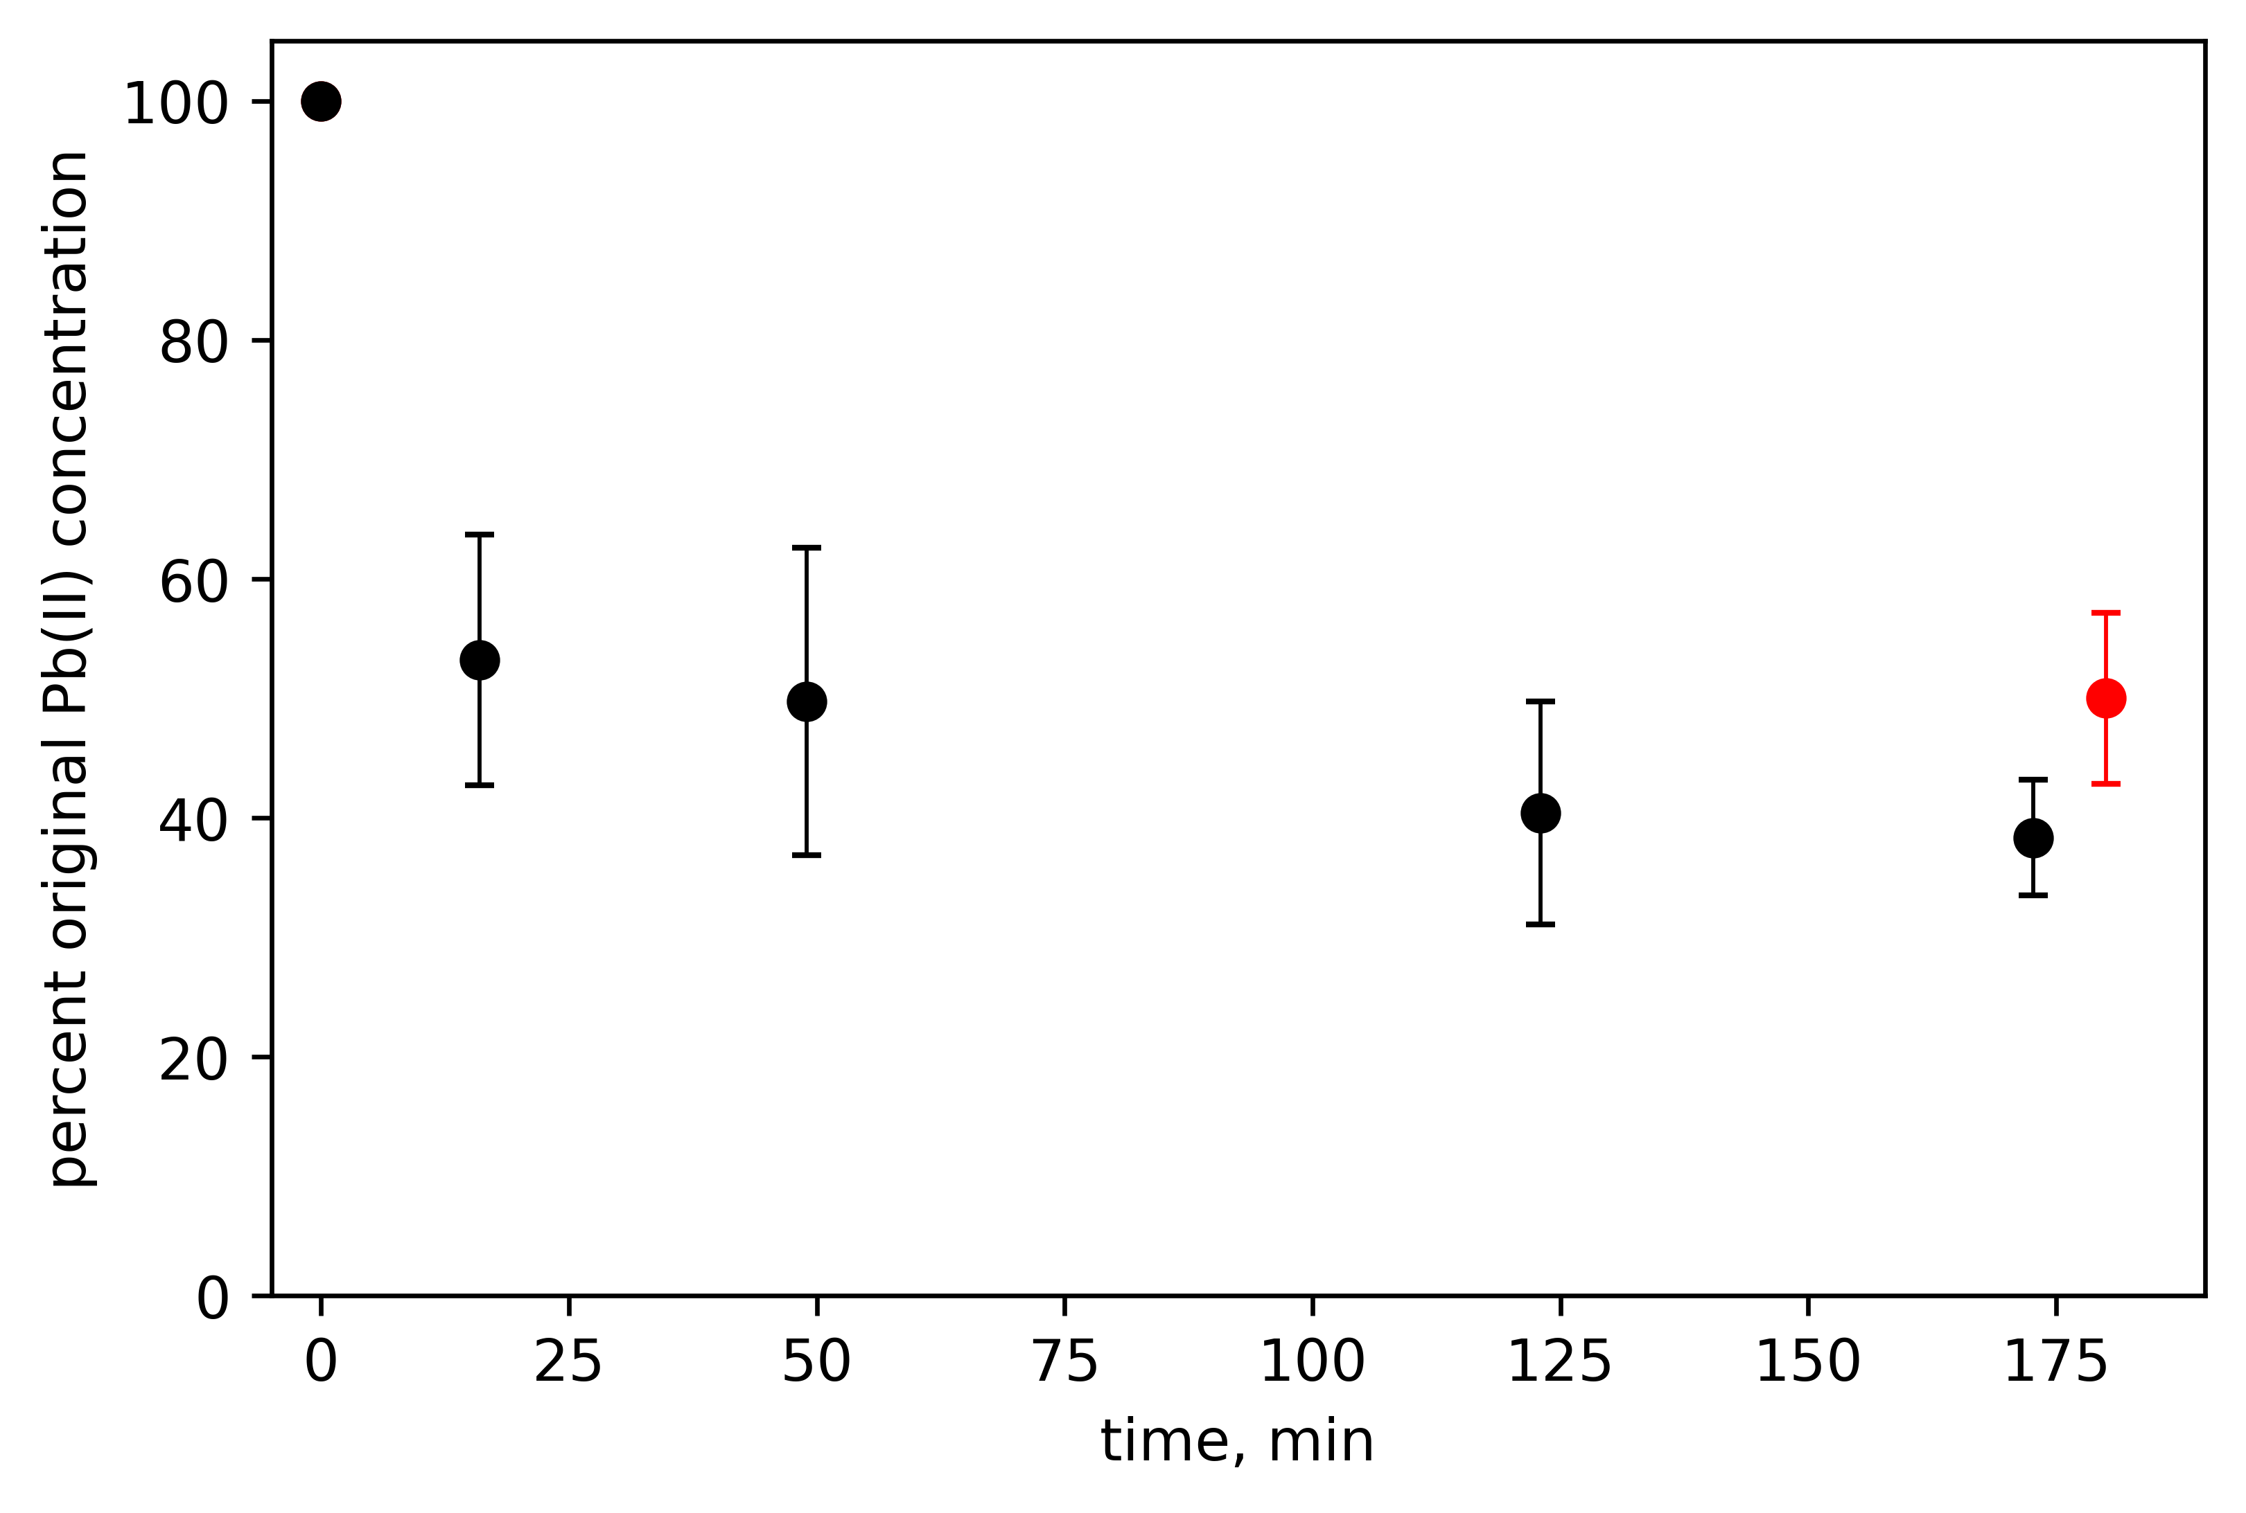
These results suggest that biosorption is responsible for the initial, rapid removal of Pb(II) from solution. Since both biosorption and precipitation of Pb(II) occur on the surface, it is likely that the biosorption of lead ions onto bacteria cell walls is a necessary precursor to the precipitation of Pb(II) to PbS or Pb(0).

Figure 2: Percent lead remaining in solution as a function of time after the addition of the NaN₃-sterilized consortium. The red data point represents the percentage lead in solution for the living consortium after 3 h as measured by Hörstmann et al. (2020).
Conclusions
Sodium azide successfully inhibited metabolic activity of the consortium without damaging the cell walls of bacteria, allowing for Pb(II) removal through abiotic mechanisms to be studied. It was found that 61.7 ± 4.86 % of Pb(II) is removed in 3 h by non-living bacteria. FTIR spectroscopy supported the chemisorption of lead onto functional groups as being responsible for this removal. The amount of consortium dosed and the initial Pb(II) concentrations used were found to have a non-linear effect on lead removal, with Pb(II) concentration gradient being a limiting factor at concentrations less than 150 mg L⁻¹ whereas binding sites become the limiting factor above 150 mg L⁻¹.
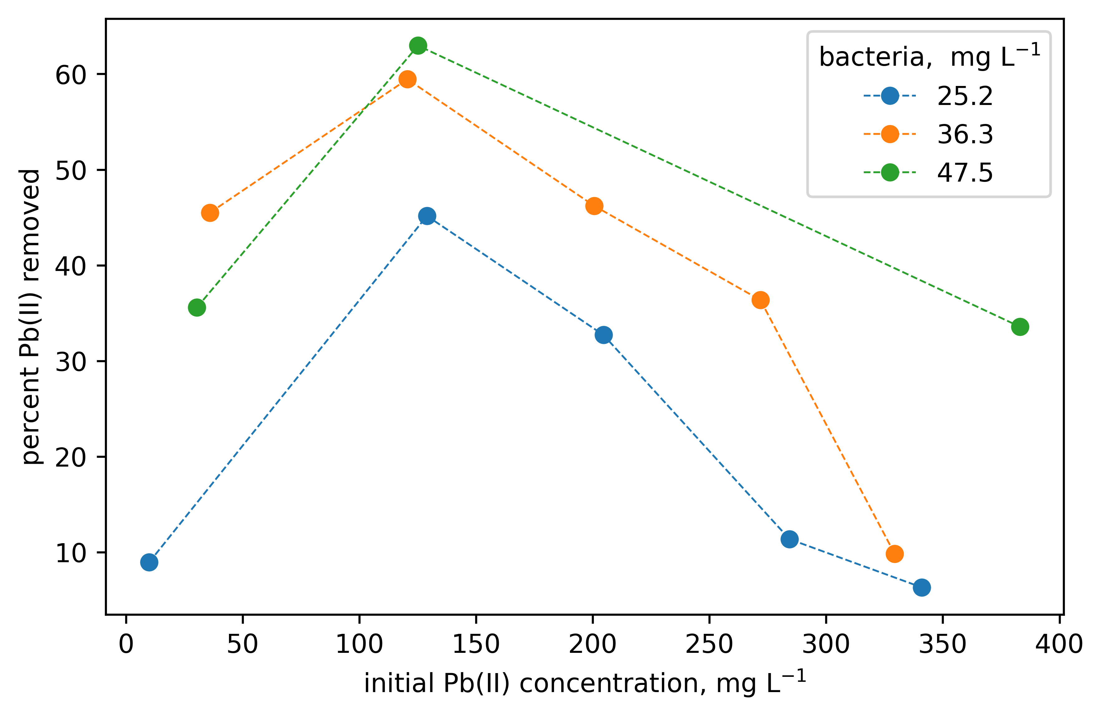
Figure 3: The effects of NaN₃-sterilized bacteria concentration and initial Pb(II) concentration on lead removal. The concentration of bacteria is given as a dry mass.
Acknowledgments
This work is based on the research supported in part by the National Research Foundation of South
431 Africa (Grant Numbers 106938 and 121891).
References
Ahmed, Y.M., Mamun, A. Al, Muyibi, S.A., Al-Khatib, M.F.R., Jameel, A.T., AlSaadi, M.A., 2010. Effect of Adsorbate Initial Concentration on the Removal of Pb from Aqueous Solutions by Carbon Nanofibers, in: 24th Symposium of Malaysian Chemical Engineers (SOMChE 2010) and 1st International Conference on Process Engineering and Advanced Materials 2010 (ICPEAM2010). Kuala Lumpur, pp. 15–17.
Brink, H.G., Hörstmann, C., Feucht, C.B., 2019. Chem. Eng. Trans. 74, 1453–1458.
Brink, H.G., Lategan, M., Naudé, K., Chirwa, E.M.N., 2017. Int. Conf. Energy, Environ. Clim.
Cabrol, L., Quéméneur, M., Misson, B., 2017. J. Microbiol. Methods 133, 62–65.
Chang, J.S., Law, R., Chang, C.C., 1997. Water Res. 31, 1651–1658.
Dittrich, M., Sibler, S., 2005. J. Colloid Interface Sci. 286, 487–495.
Duncan, J.R., Stoll, A., Wilhelmi, B., Zhao, M., van Hille, R.P., 2003. The use of algal and yeast biomass to accumulate toxic and valuable heavy metals from wastewater: WEC Report No. 616/1/03.
Fein, J.B., Daughney, C.J., Yee, N., Davis, T.A., 1997. Geochim. Cosmochim. Acta 61, 3319–3328.
Fomina, M., Gadd, G.M., 2014. Bioresour. Technol. 160, 3–14.
Francioso, O., Rodriguez-Estrada, M.T., Montecchio, D., Salomoni, C., Caputo, A., Palenzona, D., 2010. J. Hazard. Mater. 175, 740–746.
Fu, F., Wang, Q., 2011. J. Environ. Manage. 92, 407–418.
Haas, J.R., Dichristina, T.J., Wade, R., 2001. Chem. Geol. 180, 33–54.
Van Hille, R.P., Antunes, A.P.., Sanyahumbi, D., Nightingale, L., Duncan, J.R., 2003. Development of integrated biosorption systems for the removal and/or recovery of heavy metals from mining and other industrial wastewaters, and determination of the toxicity of metals to bioremediation processes: WRC Report No. 1243/1/03.
Hörstmann, C., Brink, H.G., Chirwa, E.M.N., 2020. Sustainabilty.
Kang, C.H., Oh, S.J., Shin, Y.J., Han, S.H., Nam, I.H., So, J.S., 2015. Ecol. Eng. 74, 402–407.
Lieber, E., Rao, C.N.R., Dingle, H.E., Teetsov, J., 1966. J. Chem. Eng. Data 11, 105.
Liu, Y., Alessi, D.S., Owttrim, G.W., Kenney, J.P.L., Zhou, Q., Lalonde, S. V., Konhauser, K.O., 2016. Geochim. Cosmochim. Acta 187, 179–194.
Liu, Z., Huang, Y., Zhao, G., 2016. BioResources 11, 3178–3190.
Lu, H., Zhang, W., Yang, Y., Huang, X., Wang, S., Qiu, R., 2012. Water Res. 46, 854–862.
Masoumi, F., Khadivinia, E., Alidoust, L., Mansourinejad, Z., Shahryari, S., Safaei, M., Mousavi, A., Salmanian, A.H., Zahiri, H.S., Vali, H., Noghabi, K.A., 2016. J. Environ. Chem. Eng. 4, 950–957.
Mathew, B.B., Krishnamurthy, N.B., 2018. Groundw. Sustain. Dev. 7, 313–327.
Naik, M.M., Khanolkar, D., Dubey, S.K., 2013. Ecotoxicol. Environ. Saf. 98, 1–7.
Ngwenya, B.T., Sutherland, I.W., Kennedy, L., 2003. Appl. Geochemistry 18, 527–538.
Peens, J., 2018. Pb (II)-Removal From Water Using Microorganisms Naturally Evolved to Tolerate Pb(II)-Toxicity. University of Pretoria, Pretoria.
Peens, J., Wu, W.Y., Brink, H.G., 2018. Chem. Eng. Trans. 64, 439–444.
Puyen, Z.M., Villagrasa, E., Maldonado, J., Diestra, E., Esteve, I., Solé, A., 2012. Bioresour. Technol. 126, 233–237.
Salehizadeh, H., Shojaosadati, S.A., 2003. Water Res. 37, 4231–4235.
Selatnia, A., Boukazoula, A., Kechid, N., Bakhti, M.Z., Chergui, A., Kerchich, Y., 2004. Biochem. Eng. J. 19, 127–135.
Tao, P., Li, Y., Rungta, A., Viswanath, A., Gao, J., Benicewicz, B.C., Siegel, R.W., Schadler, L.S., 2011. J. Mater. Chem. 21, 18623–18629.
Uslu, G., Tanyol, M., 2006. J. Hazard. Mater. 135, 87–93.
Vijayaraghavan, K., Yun, Y.S., 2008. Biotechnol. Adv. 26, 266–291.

